**How to play the game**  
  
Knight Line’s rules are very simple. Just as in games like Carcassonne and Hive, there’s no board; instead, there’s an imagined, indefinite grid. The players have one stack of 24 tiles each, and these stacks are placed side to side like this:

[](https://boardgamegeek.com/image/2247054)

Set up. My picture.

There’s only one kind of move in Knight Line, which may seem slightly complicated if you have no experience of Chess, namely that of the knight piece in said game. This means two spaces forward in any direction orthogonally, i.e. not diagonally, and one space to the left or to the right.

[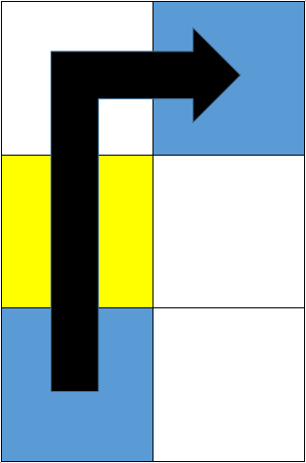](https://boardgamegeek.com/image/2247052)

How you move. My picture.

The player may move one or more tiles from a stack, but must leave at least one tile behind. The stack may be moved over any other stack, but must placed on an empty space. Just as in games like Hive and For the Win, the moved stack must border to another pile – horizontally, vertically, or diagonally – and it may not be placed “in the void”. In other words, it must all “hold together”. Below are some examples of legal moves, marked black, and illegal moves, marked red.

[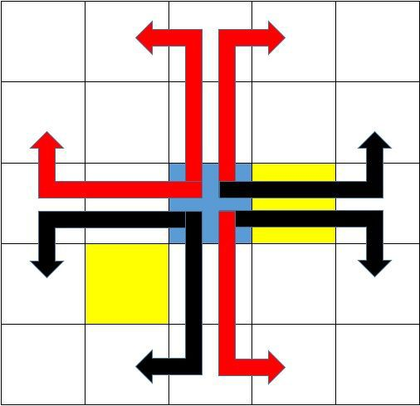](https://boardgamegeek.com/image/2247053)

Examples of legal moves (black) and illegal moves (red). My picture.

Obviously, the further the game progresses, the smaller the stacks becomes, and eventually, there will only be one or two tiles in each stack. Thus, the players must economise with the tiles, and be careful not move too many at a time.  
  
The objective of the game is to get four tiles in a row, either horizontally, vertically, or diagonally. Although unlikely, a player may lose by not being able to move.  
  
**Play value**  
  
Knight Line is more difficult than it seems because of the unusual rules for movement. Contrary to most other abstract strategy games, you can’t simply add a piece or move a piece to an adjacent square. This requires rather intricate planning and manoeuvring.  
  
I, for one, find Knight Line to be surprisingly stimulating and challenging. It’s essentially a combinatory game in which you have to think at least two or three moves ahead. It becomes very evident when your opponent has lined up three tiles in a row; because of the unusual rules for movement, it’s seldom, if ever, certain that a stack will be in reach to stop your opponent unless you have planned ahead.  
  
I haven’t really played Knight Line enough times to dare giving a verdict on its replay potential. The limited number of opening moves certainly suggests that it’s solvable, but as with most other abstract strategy games, it would take an extremely experienced and skilled gamer to figure this out quickly.  
  
I’ve played quite a few abstract strategy games by now, and I don’t think that Knight Line resembles any other game, really. The different mechanisms can certainly be found in other games, but I’d say that the combination of mechanisms is unique, or at least close to unique. In other words, this game is not ten a penny and forces you to think in new ways.  
  
If you like abstract strategy games and have the required components, I think this is a no-brainer – you ought to give Knight Line a try.